Criminology - iii.

Exactly what IS a serial killer?
Remember, the condition of being a psychopath, and why it’s a reference in criminology. We don’t have to explain what makes the acts of a psychopath ‘wrong’. As social animals, we simply cannot accept entirely self – referential acts as being justifiable.
Serial killers can be defined only by negation;
- Some murderer’s have rational justification for their acts.
- Some can justify a series of murders rationally to others.
- A mass murderer kills several victims in one event.
- A spree killer usually commits suicide as part of the event.
‘Jack the Ripper’ is the archetype; London in the 1880s.
Ted Bundy is said to be an obvious example too. U.S. 1979 – 89.

The Whitechapel Murders.

Note to self – scan in p84 of Joyce.
Apart from pshycopathy, a frequent explanation of serial killing is ‘anomie’.
The criminal is separate from their society.
Prominent criminologist Siegel in 2012 said that the ‘....causes of serial murder elude criminologists,...’ going on with factors that can be identified;
- Mental illness
- Sexual frustration
- Neurological damage
- Childhood abuse
- Neglect
- Smothering maternal relationship
- Anxiety
- Narcissism..............

The Main Motives:

- Money.
- Pleasure.
- Power.
- Mental illness.
- Mission. 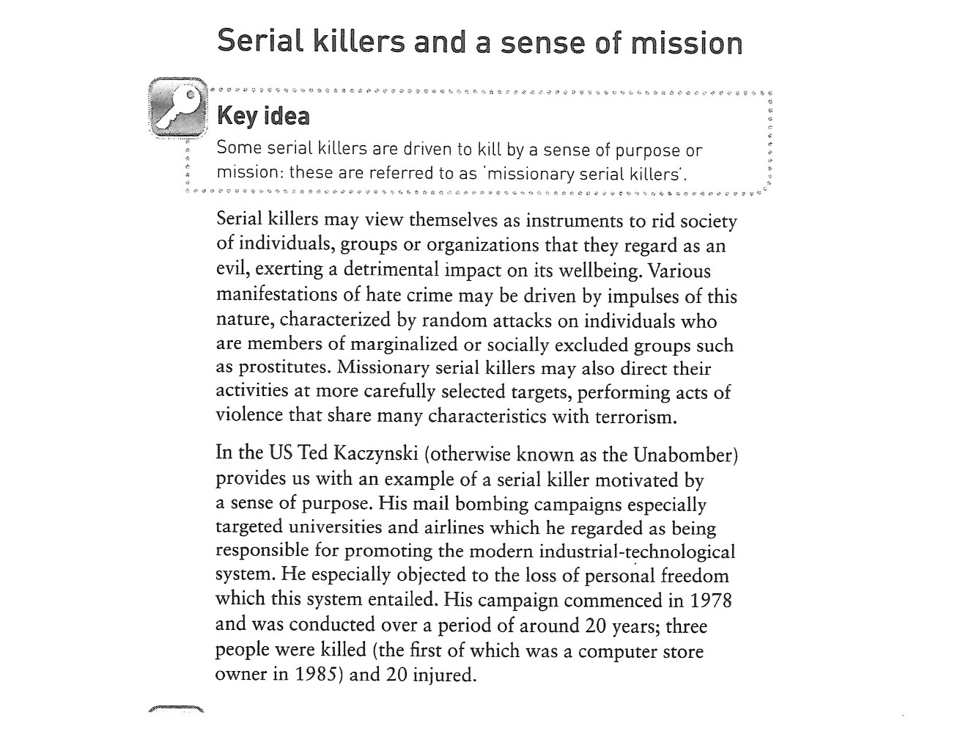
Our problem – if there is no ‘typical’ profile of a serial killer, can criminologists help to prevent such atrocities?

Criminal profiling.

- Began with an American Thomas Bond in trying to i.d. The Ripper.
- FBI developed it – ‘The Behavioural Science Unit’ 1970s.
- Central idea – build a ‘picture’ of the criminal’s personality from detailed examination.
- Key areas:
- Antecedent.
- Modus operandi.
- Body disposal.
- Offender’s behaviour after murder.
- The crime scene:
- Organised – indicates planning.
- Disorganised – suggests spontaneity.
The criminologist then makes a ‘picture’ of the criminal.

Can profiling help to prevent atrocious crimes, or, is it dangerous to generalise.?

